FTF FY 2023 Performance Scorecard USAID Zimbabwe

This Feed the Future (FTF) Performance Scorecard assesses the USAID Zimbabwe progress toward FY 2030 Performance Targets.

# Performance Overview



The FY 2023 **On track** value is determined by drawing a line from the baseline (FY 2022) to the FY 2030 Target. For FY 2023, Performance Targets are considered **On track** if they have reported at least 90% of that value.

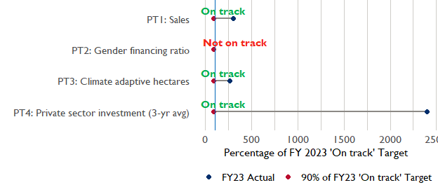

**Note:** *For Performance Target 2 (Gender financing ratio), the target is to increase financing to females for those OUs that are already achieving parity ($1).*

*For Performance Target 4 (PSI), all targets are relative to the last three years’ reporting. In future years, the interim targets may increase.*

*For Performance Target 5 (MDD-W), all FY23 actual values are also the baseline, and may have been collected in a prior year. See the detail page for more information.*

*See detailed* [*methodology document*](https://docs.google.com/document/d/13n-43ppFiGKauscQ7HaAiQDCM4DssGEgRdq2fMyTDn0/edit) *here. If you have questions, please email the FTF Data and Analytics team at* [refs.adl.da@usaid.gov](mailto:refs.adl.da@usaid.gov).

### Performance Target (PT) Details

This section shows PT scores for each applicable PT for USAID Zimbabwe.

## Performance Target 1: Value of annual sales of producers and firms receiving USG assistance



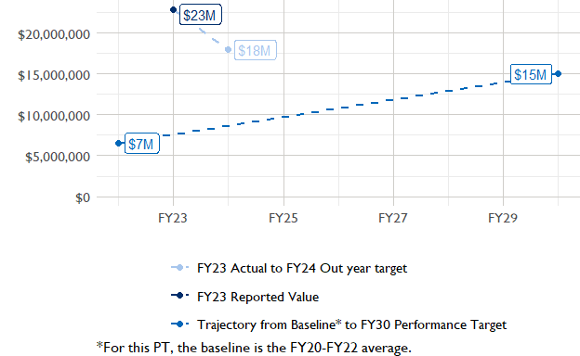

In FY 2023, USAID Zimbabwe had 5 activities that aligned the ‘Value of annual sales from producers and firms receiving USG assistance’ (EG.3.2-26), and 4 contributed to the sales total of $22,930,000.

###### Performance Target 2: Value of financing accessed by female FTF participants per $1 of financing accessed by male FTF participants



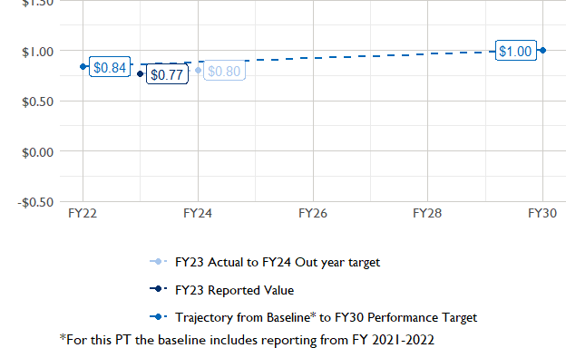

In FY 2023, USAID Zimbabwe had 1 IMs/Activities that reported all four sex disaggregates needed to contribute to PT2. The total value of financing among all activities, regardless of disaggregates, was $270,000 (EG.3.2-27 total), with $270,000 that was disaggregated by females and males, and an additional $0 to ‘mixed’ firms that have both males and females, and $0 that was not sex disaggregated.

###### Performance Target 3: Number of cultivated hectares under climate adaptation/climate risk management practices and technologies with USG assistance



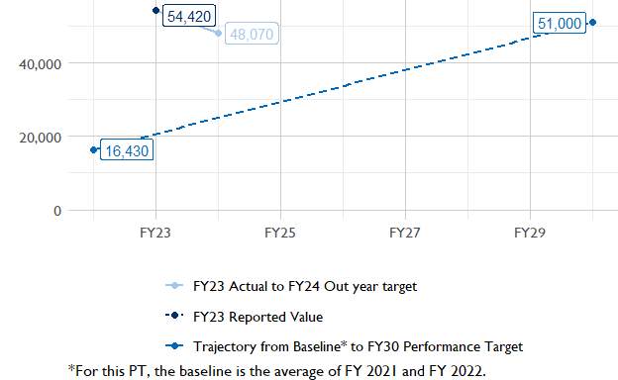

In FY 2023, Zimbabwe had 8 activities that aligned the indicator for hectares under improved management practices (EG.3.2-25). Of those activities, 3 reported on the ‘Climate adaptation/climate risk management’ disaggregate and contributed to the OU total for this PT.

###### Performance Target 4: Value of private sector investment leveraged by the USG to support food security and nutrition



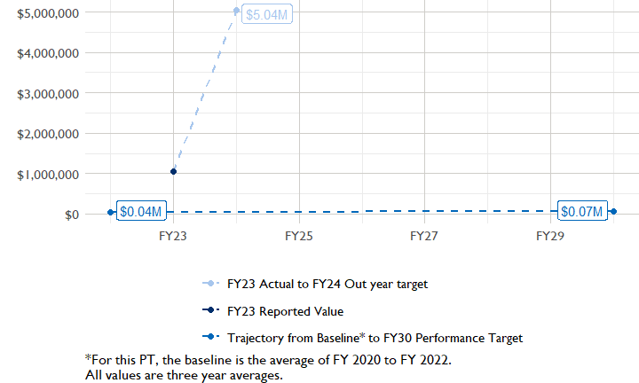

In FY 2023, Zimbabwe had 1 activity that aligned the private sector investment indicator (EG.3.1-15/-14), ‘Value of new private sector investment leveraged by the USG to support food security and nutrition [IM-level]’, and 1 contributed to the OU total in FY 2023.

###### Performance Target 5: Percent of women consuming a diet of minimum diversity (MDD-W)



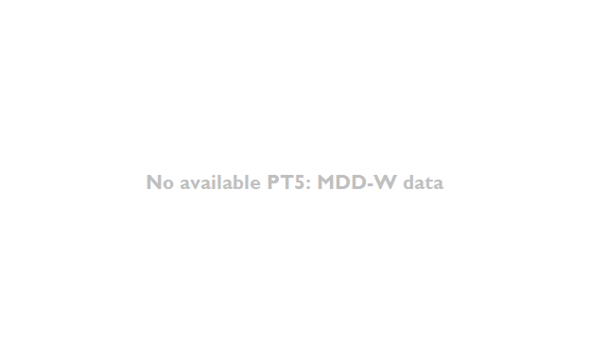

PT5 is not available for USAID Zimbabwe.

### National Context

National level data was collected from the [World Bank’s Open Data portal](https://data.worldbank.org/) that measures key indicators at the national level.

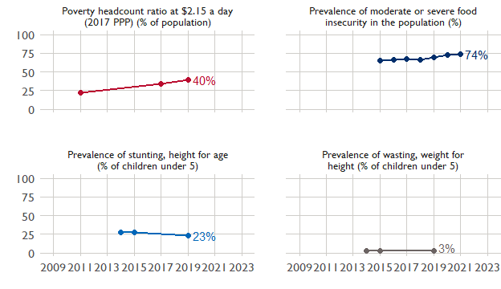

## Agricultural Transformation Index Score

The IFPRI Agricultural Transformation Index (ATI) Score is a high level indicator of the status of agricultural market systems in each country.

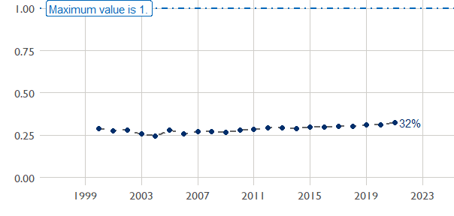

## Budget Trend

At the Operating Unit level, the Performance Targets are based in part on the FY 2024 budget request. The budget chart below includes EG.3 money only.

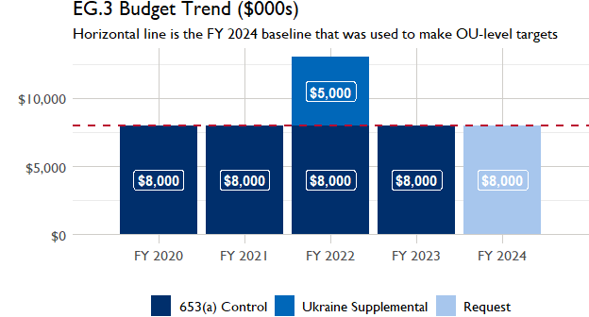

## Active Portfolio

The following activities are considered “active” based on their reporting in FY 2023 and expected FY 2024 reporting. The Analytics, Data and Learning Division defines an “active” activity as one that reported targets, actuals, or deviation narratives for the current year (FY 2023), or the next out year targets (i.e. FY 2024).

## Top Activities (Award Disbursements and Results)

This section highlights the 5 activities (out of the total 8 in the USAID Zimbabwe (ZIMBABWE) portfolio) that have the highest level of FY 2023 annual disbursements and highest reported values for the relevant indicators. The first table below shows activities with the highest total transaction amounts. The columns to the right indicate if these activities are reporting on relevant PT indicators.

| Award Number | Activity Code | Activity Name | FY23 Disbursements | PT1 | PT2 | PT3 | PT4 |
| --- | --- | --- | --- | --- | --- | --- | --- |
| 72061320C00001 | 1296 | Fostering Agribusiness for Resilient Markets | $4,603,531 | X | X | X | X |
| 7200AA18D00022 | 1297 | RESILIENCE ANCHORS | $2,415,672 | X | - | - | - |
| AID-BFS-IO-17-00005 | 1289 | 104844: Evaluating Agro-ecological Management Options for Fall Armyworm in Zimbabwe | $1,838,165 | - | - | - | - |

The next table (below) shows the activities that reported the highest values for the relevant PT indicators. The total disbursements are included, if available.

| Award Number | Activity Code | Activity Name | Total Disbursements | Sales | Hectares | PSI |
| --- | --- | --- | --- | --- | --- | --- |
| 72061320C00001 | 1296 | Fostering Agribusiness for Resilient Markets | $4,603,531 | $21,425,163 | 32 066 | $3,134,319 |
| 72DFFP20CA00007 | 4635 | Takunda | NA | $1,322,391 | 8 157 | NA |
| 72DFFP20CA00008 | 931 | Amalima Loko | NA | $148,203 | 14 201 | NA |
| 7200AA18D00022 | 1297 | RESILIENCE ANCHORS | $2,415,672 | $36,814 | NA | NA |
| AID-613-C-15-00001 | 1291 | Feed the Future Zimbabwe - Livestock Development | NA | NA | NA | NA |
| !! Not reported !! | 1286 | ZIM-15-002: Development Credit Authority (DCA) | NA | NA | NA | NA |
| AID-BFS-IO-17-00005 | 1289 | 104844: Evaluating Agro-ecological Management Options for Fall Armyworm in Zimbabwe | $1,838,165 | NA | NA | NA |
| !! Not reported !! | 6461 | Feed the Future Mechanization and Extension Activity | NA | NA | NA | NA |

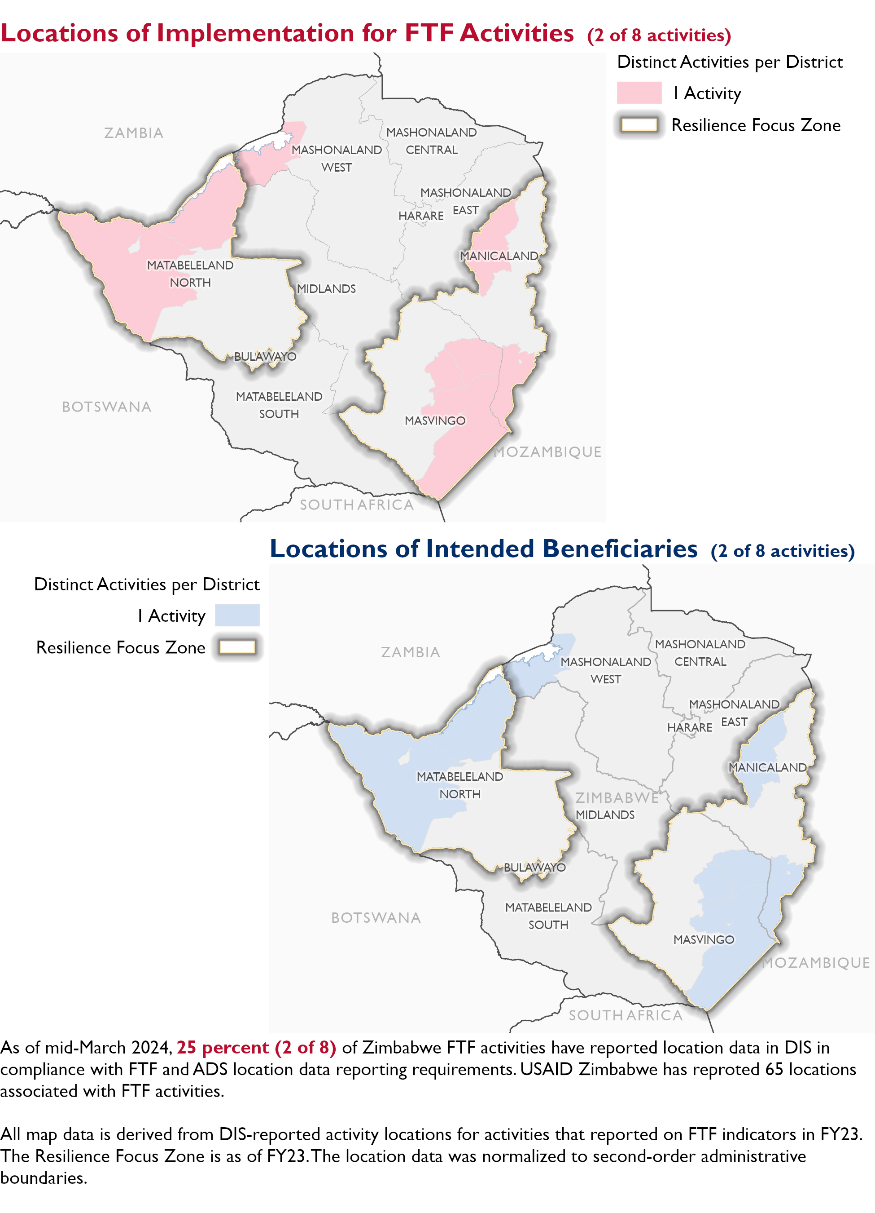

### Appendix 1: Response to “Not on track” Performance Targets

This section provides space for USAID Zimbabwe to provide an explanation of why the following PTs are not on track and how you could adjust to be on track in the coming year(s). To help in your response(s), the relevant section of the FTF/GFS Key Issue Narrative (KIN) is provided, as it *may be* useful in drafting a responses. Note that the KIN is addressing the sum of the out year targets (FY 2023) set by the USAID Zimbabwe activities that are reporting on each PT. The FY 2023 out year targets were set prior to the establishment of the FY 2030 Performance Targets, so the below explanations from the KIN may not apply to the Performance Target deviation.

* In Section 4 of the FTF KIN, your OU discusses FY24 and FY25 targets, while these Scorecards are addressing progress against a trajectory from historical reporting to your OU’s FY30 target. Also, the FY 2023 out year targets were set prior to the establishment of the FY 2030 Performance Targets. Therefore, the below explanations from the KIN may not apply to these FY30 Performance Target deviations.
* These responses will be used to compile a Congressional report, the GFSS Implementation Report, to discuss progress against the FTF FY 2030 Performance Targets, as mandated by the GAO.
* Only PTs that are ‘Not on Track’ require review and explanation from the OU.

Include in the response:

1. An explanation of why this target is not on track. Explanations may include that the OU/Mission was not aware of the target prior to planning activities.
2. Planned actions for ‘not on track’ targets. Planned actions may include the launch of new activities, building awareness, holding portfolio reviews, or other suggestions.

## Performance Target 2: Gender financing ratio [Not on Track]

*Excerpt from FY23 KIN Section 4 to consider:* value of finance accessed by females per dollar of finance accessed by males was $0.75 against a target of $1.0. The target was not met. The target was not met due to the poor economic environment coupled with unfavorable monetary policies (high interest rates for borrowers) that negatively affected farmers’ access to finance. Some pivots/adjustments that Mission is taking to address this as part of our adaptive management is scaling up the Village Savings & Lending Loan Schemes to enable smallholder farmers to have access to funds that could be used as down payments in accessing loans or for outright purchase of farm inputs. The Mission is also designing an Access to Finance activity that will explore innovative and creative ways of incentivizing the financial institutions to increase access to credit for our beneficiaries, especially for those able to make down payments. FY 2024 targets are lower than the FY 2023 actuals due to the time needed for the formation and training of saving groups, and the start up phase of the Mission’s new Access to Finance activity that is scheduled to be awarded during the fiscal year.

#### Enter USAID Zimbabwe (ZIMBABWE) response below: